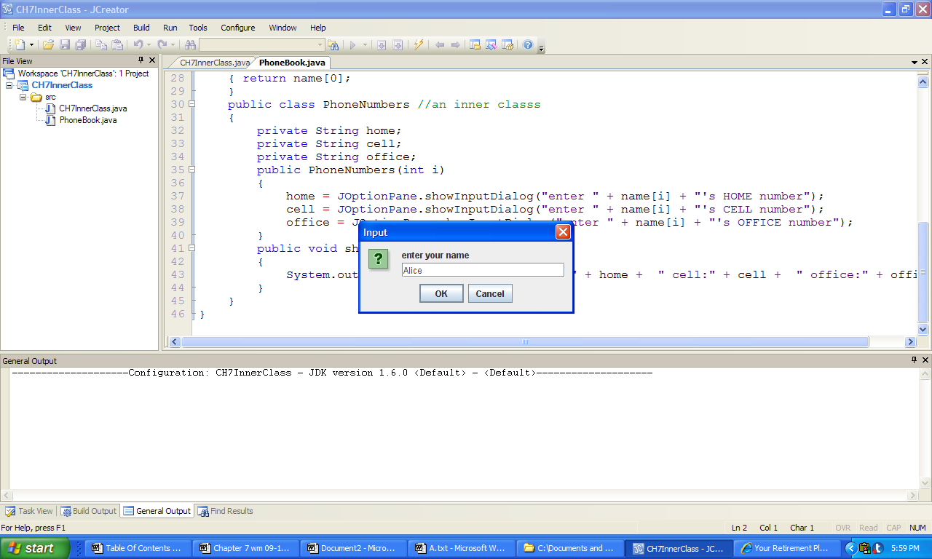 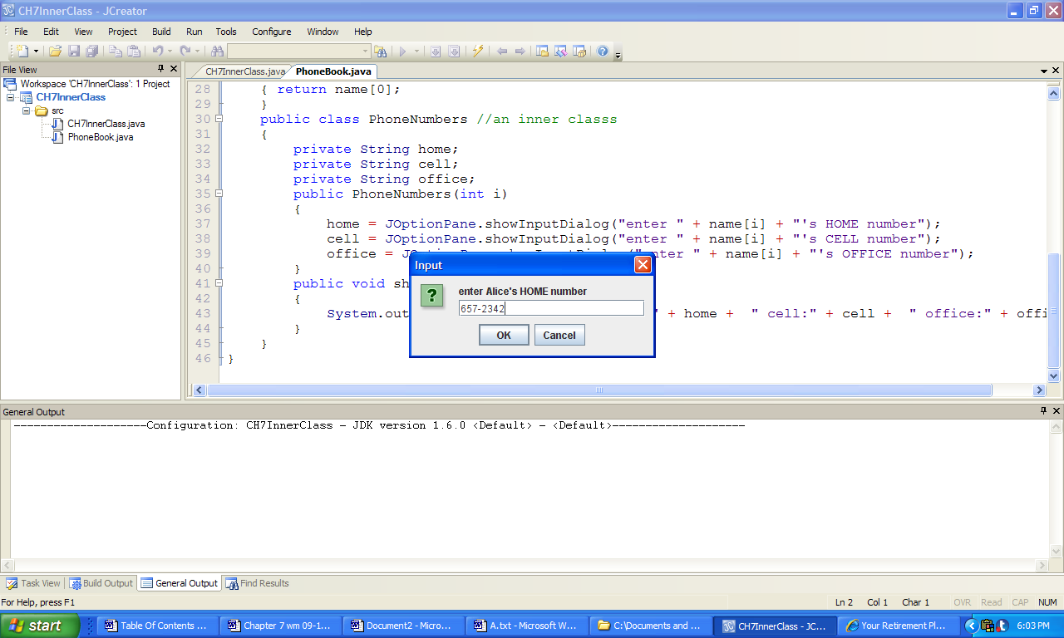

a) b)

***Console Output:***

Name: Alice

PhoneNumbers: home:657-2342 cell:574-8976 office:345-6589

Name: Tom

PhoneNumbers: home:367-4367 cell:754-3564 office:386-1212

Name: Annie

PhoneNumbers: home:456-4698 cell:765-8294 office:839-5623

**Figure 7.29 Two typical inputs to the application InnerClass and a typical set of outputs.**